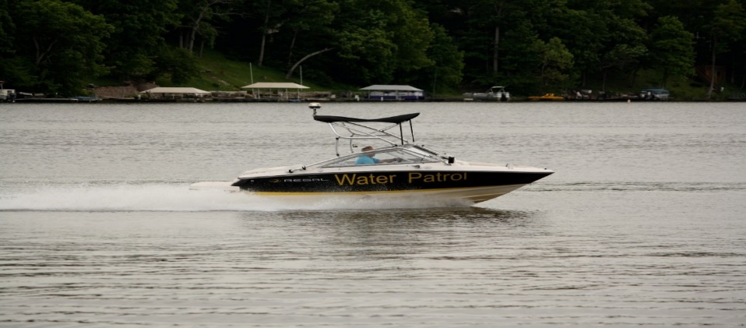
BOATING SAFETY COURSE
Held at C.A. Clubhouse
ANY CURRENT RESIDENT THAT ANTICIPATES A CHANGE OF WATERCRAFT MUST TAKE A BOATING SAFETY COURSE BEFORE A NEW/DIFFERENT WATERCRAFT CAN BE APPROVED FOR USE ON BOTH LAKES.
NEW RESIDENTS THAT ARE CONSIDERING PUTTING A WATERCRAFT ON EITHER LAKE MUST ALSO TAKE THE BOATING SAFETY CLASS BEFORE HAVING THEIR WATERCRAFT APPROVED FOR USE ON THE LAKES.
THE CLASSES ARE ALSO BEING EXPANDED TO INCLUDE ALL RESIDENTS OF THE ASSOCIATION THAT HAVE A CLASS 5, 6, 7. AND 8 BOATS. YOU MUST TAKE THE BOATING SAFETY CLASS BY THE END OF 2018 OR BEFORE MARCH 31, 2019 IN ORDER TO REGISTER/REREGISTER YOUR BOAT IN 2019.
THE COURSE IS FREE AND WILL TAKE APPROXIMATELY 45 MINUTES.
CALL THE WATER PATROL OFFICE AT 636-625-3120 TO BE PUT ON A LIST FOR THE UPCOMING CLASSES.
FOLLOWING ARE THE UPCOMING CLASS DATES FOR OCT/NOV 2018.

TUE 10/16 @ 7PM TUE 10/23 @ 7PM TUE 10/30 @ 7PM
SAT. 11/10 @ 11 AM TUE. 11/13 @ 7 PM
SAT. 11/17 @ 11 AM TUE. 11/20 @ 7 PM
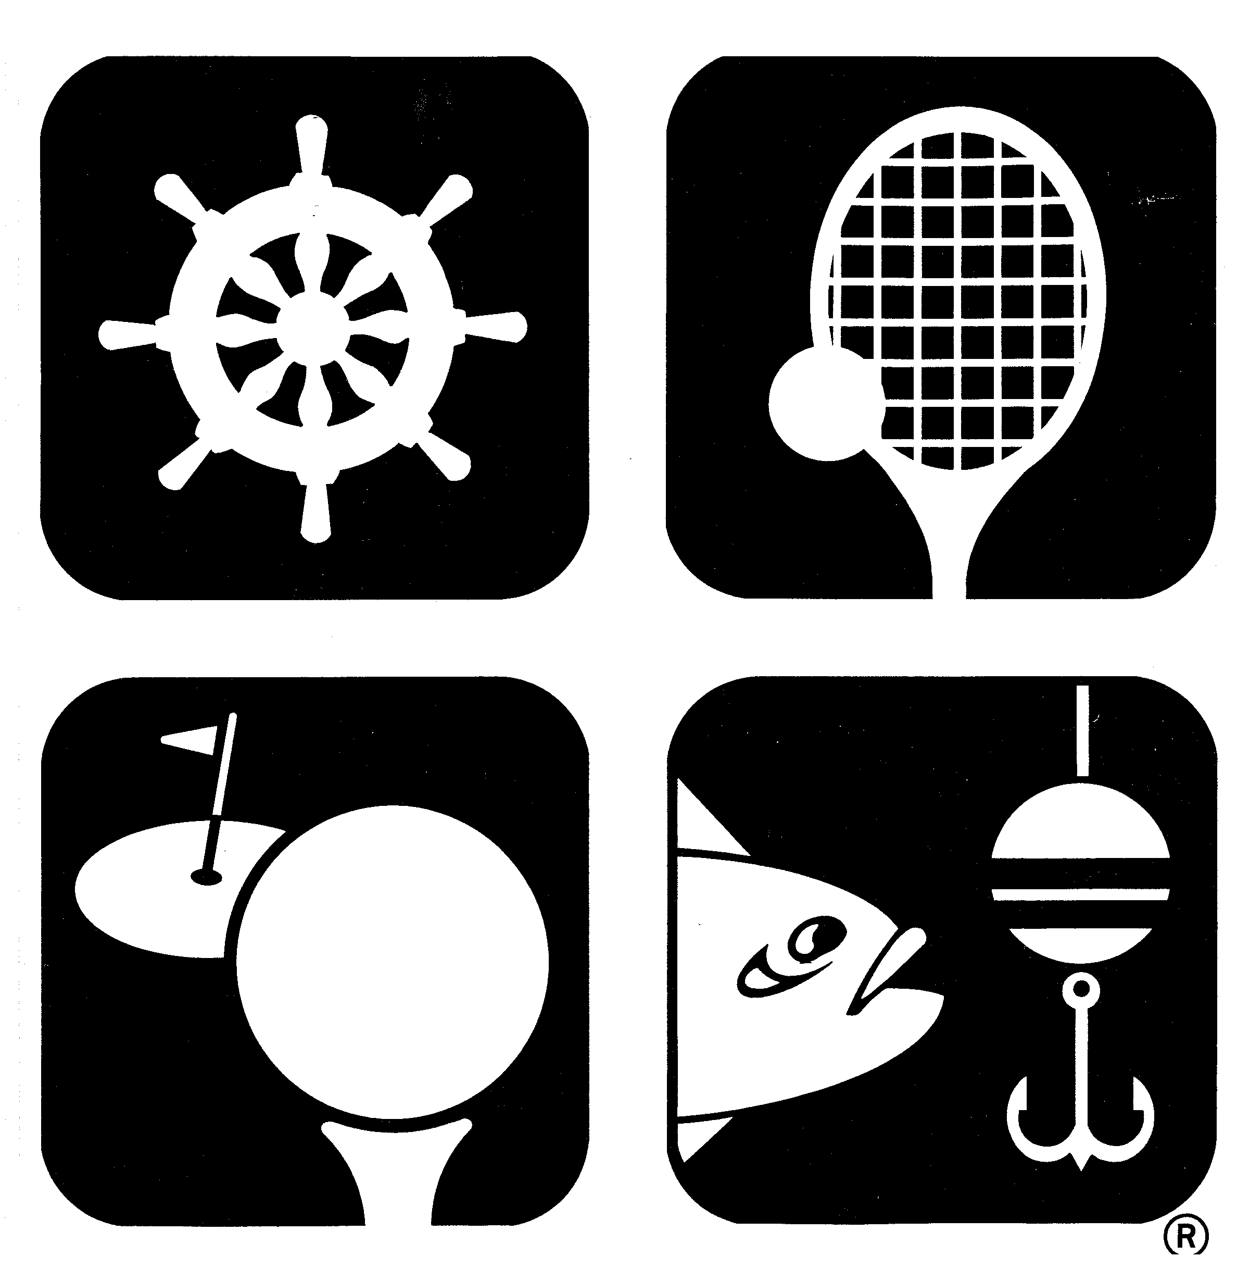

Take advantage of our new Boater Safety Course taking place monthly

