Lake St. Louis Community Association
COURTS COMMITTEE MEETING
March 13, 2023 / 5:00 PM
Next Meeting: April 10, 2023, 5pm

Committee Members in Attendance:
- Rick Knight
- Alex Kott
- Ann-Marie Stagoski
- Diane Seerey
- Sally Henderson
- Stephanie Stone
- Bill Beach

Non-Committee Members in Attendance:
- Jim Dodds – Board Liaison

Called to order at 5:03 p.m.

Minutes from February 13, 2023 LSL CA Courts Committee meeting had been distributed to all committee members via email. There were no suggested changes to those minutes as written. Stephanie Stone made the motion to approve the 2/13/23 minutes with 2nd provided by Diane Seerey. Committee voted unanimously to approve.

OLD BUSINESS:

- Committee Presentation at February LSL CA Board Meeting:
- Board approved Sally Henderson as new member of the LSL CA Courts Committee
- Board approved Courts Committee member terms approved:
  - Rick Knight, Alex Kott – 3 year terms
  - Steve Lloyd, Stephanie Stone, Ann-Marie Stagoski – 2 year terms
  - Diane Seerey, Sally Henderson, Bill Beach – 1 year terms
- League schedules – Board approved the amended pickleball schedule, which provides for Wednesday Couples Social play at the CA. (schedule is below). Tennis schedule was not approved as there is no Tennis Association as recognized by LSLCA and the tennis groups on proposed schedules are not recognized as clubs currently.

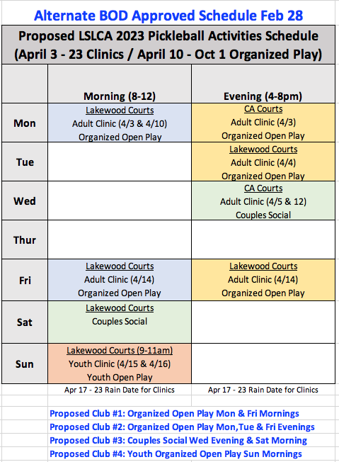

- The Board provided the following Courts Committee & Clubs Guidelines and process to be followed for submitting and approving of tennis club and pickleball club schedules:
  - Proposed clubs must be formed with leads and league schedules.
  - Clubs w/ schedules & leads to be reviewed with Courts Committee and amended as necessary.
  - Club recommendations to be presented to the board for final amendments and approvals.

NEW BUSINESS:
- The Committee discussed the creation of the various tennis clubs needed. After input from various Committee Members, the following tennis clubs were defined:
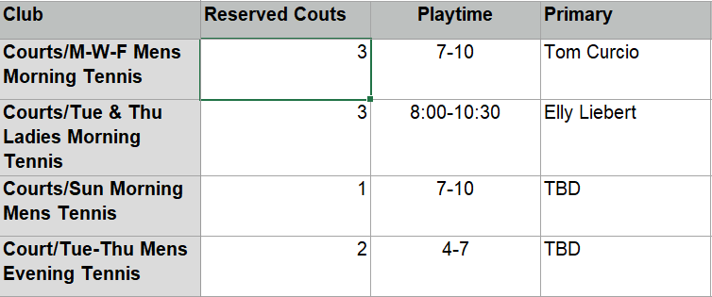

Noting that primary leads were still needed for two of the tennis clubs, Sally Henderson put forth the motion to approve the clubs with a 2nd provided by Diane Seerey. Committee voted unanimously to approve.

Alex will present the two clubs with primary leads to the Board for approval ASAP. Stephanie Stone will work to identify primary leads for the other 2 clubs and those will be presented as soon as lead has been identified.

There was discussion regarding the purpose of maintaining club rosters with the assumption being to validate the number of courts to be reserved. Jim Dodds stated he will confirm with the Board the reason behind the maintaining of such rosters. For now, tennis club rosters will be maintained as they are today. If in fact club rosters are used to determine number of courts required, suggestion was made to make it simple and have the golf shack attendant keep track of court usage during club reservation times along and weather conditions (which could impact utilization) producing valid data to be used when determining number of courts to reserve for each club. Once the purpose for the club rosters is defined, the Committee will readdress.

- EVENTS: The following list of tennis events were presented by Sally Henderson. Ann-Marie Stagoski made a motion to move forward with the events a presented with a second by Diane Seerey. The Committee voted unanimously to approve.

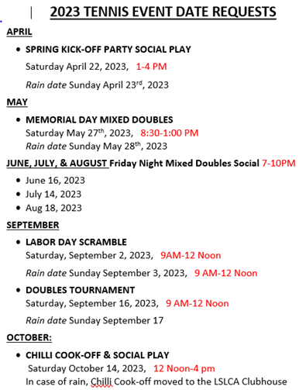

- Stephanie Stone shared the Vetta Sports Youth Clinic Schedule. Vetta did adjust the schedule to align with swim practices to ensure there was no conflict. Ann-Marie Stagoski made a motion to move the Vetta Sports Clinic Schedule, with the requirement for two courts, to the LSL CA Board for approval with a second from Stephanie Stone. The Committee voted unanimously to approve.
- Discussion regarding who would lead the various Pickleball clubs. Recommendation was for Committee members volunteer to lead the various Pickleball clubs and the request of members to email Alex Kott regarding which club they would be willing to lead. Multiple leaders per club is more than acceptable.

At 6:46 PM Stephanie Stone moved to adjourn the meeting with a second from Bill Beach. Unanimous vote from the Committee.

Respectfully submitted,

Diane Seerey
Secretary, Courts Committee

Courts Committee Action Items
March 13, 2023 Meeting

- Identify primary leads for tennis clubs (Sunday Morning Mens and Tuesday/Thursday Evening Mens) – Stephanie Stone
- Identify primary leads for all pickleball clubs – Courts Committee Members to submit their preference to Alex Kott
- Complete tennis club applications to Board for approval – Rick Knight
- Complete pickleball club applications to Board for approval – Diane Seerey
- Submit all club applications to Board for approval – Alex Kott
- Identify method for tracking of courts usage

